Professional Machine Learning Engineer

1. Architecting low-code AI solutions (13% of the exam)

2. Collaborating within and across teams to manage data and models (~14% of the exam)

3. Scaling prototypes into ML models (~18% of the exam)

4. Serving and scaling models (~20% of the exam)

5. Automating and orchestrating ML pipelines (~22% of the exam)

6. Monitoring AI solutions (~13% of the exam)

-------------------------------------------------------------------------------------------------------------

**------------------- 01 Introduction to AI and Machine Learning on Google Cloud -------------------------**

**AI/ML Architecture -----------------**

1. AI Foundations
2. AI Development - Pre-trained API, BQ ML, Auto ML (low and no code), Custom training.
3. AI Solutions

-- Data preparation --> Model development --> Model Serving

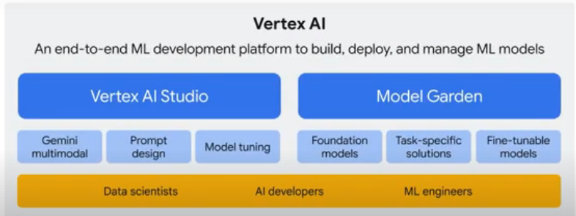

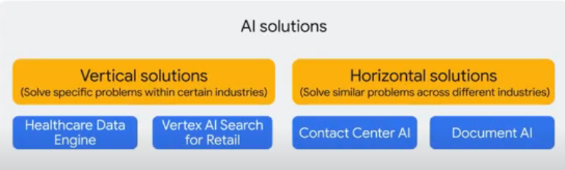

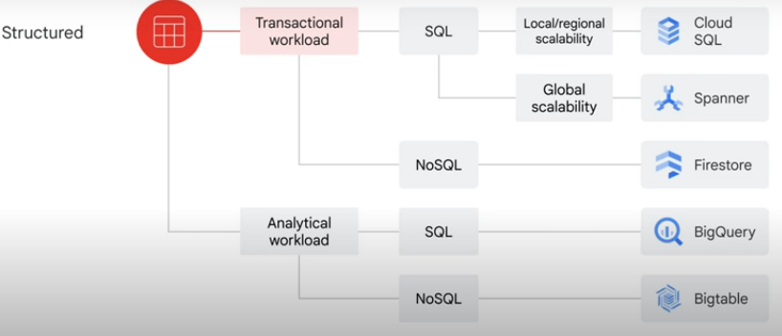

Data and AI Products –

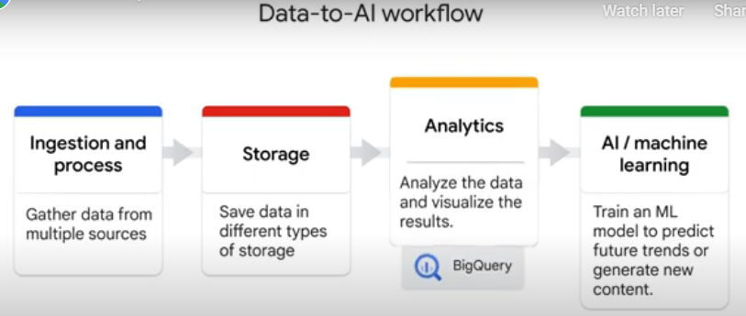

1. Ingestion and Process – Pub/Sub, Data Flow, DataProc, Cloud Data Fusion
2. Data Storage – Cloud Storage, BQ, Cloud SQL, Spanner, Big Table, Fire Store.
3. Analytics – BQ, Looker,
4. AI/Machine Learning – Gen AI – Vertex AI Studio, AutoML, Workbench, Colab Enterprise, Model Garden, Generative AI Studio.
5. AI Solutions - Document AI, Contact Center AI, Vertex AI search and Healthcare data engine.

ML Model Categories

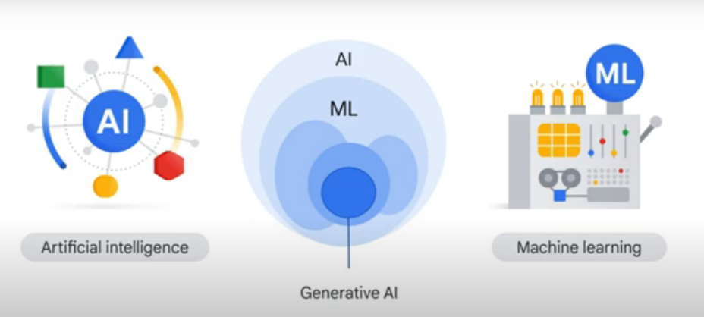

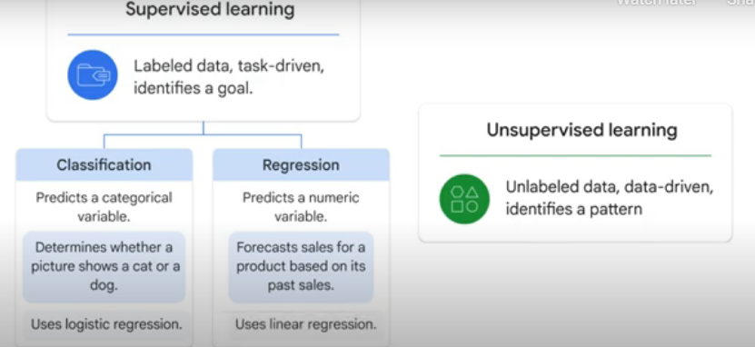

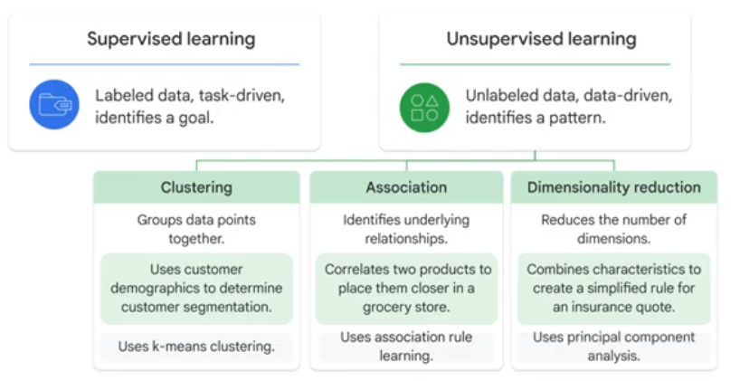

Classification vs Regression Problems?

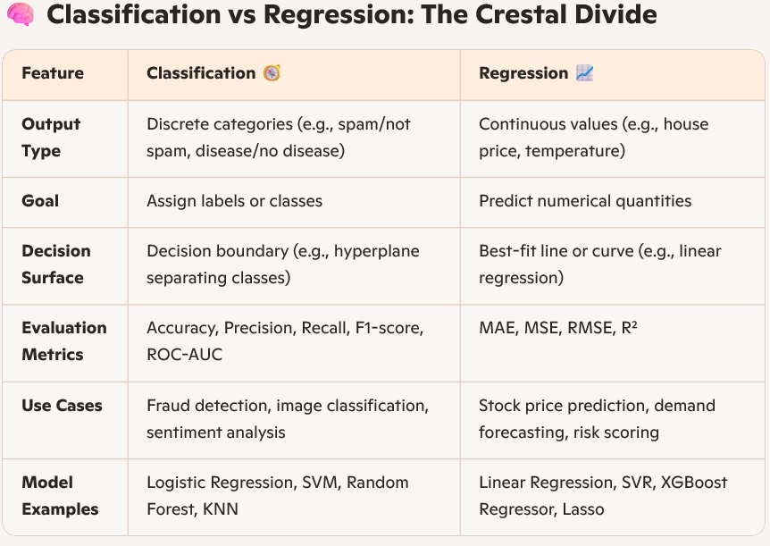

Logistic vs Linear Regression?

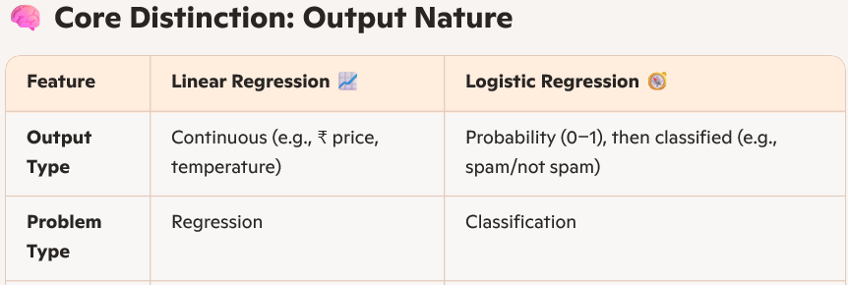

**Big Query ML ---------------------**

* **One hot encoding** converts your ***categorical data into numeric data*** that is required by a training model.
* 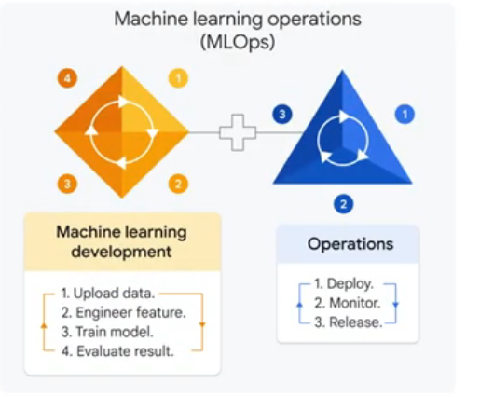
* BigQuery ML commands-

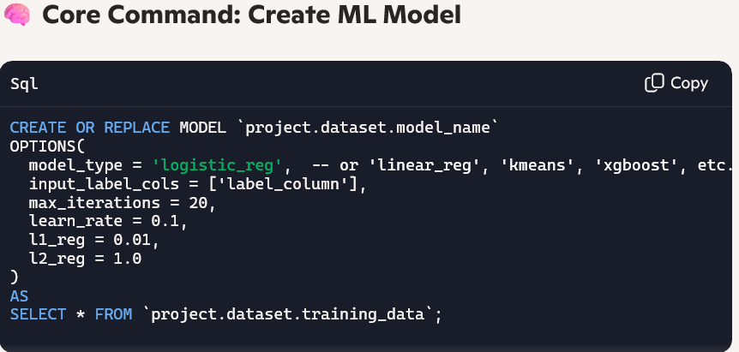

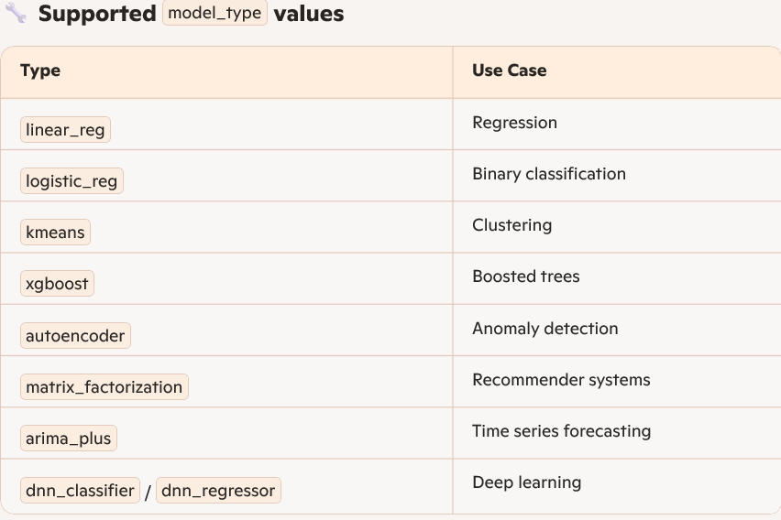

ML.EVALUATE – Evaluate Model Performance

ML.PREDICT – Predict with Model

ML.EXPLAIN_PREDICT – Explain Predictions (Feature Importance)

ML.FORECAST – Time Series Forecasting

ML.WEIGHTS – Inspect Model Weights

**-------------------------------- AI Development ----------------------------**

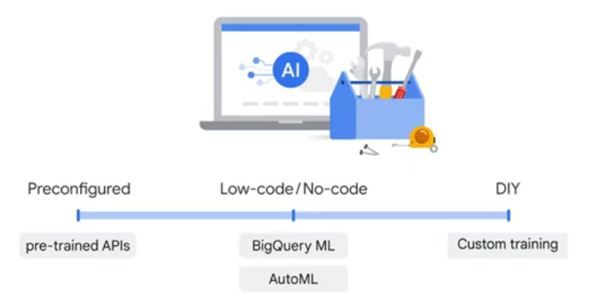

--- Pre-trained APIs

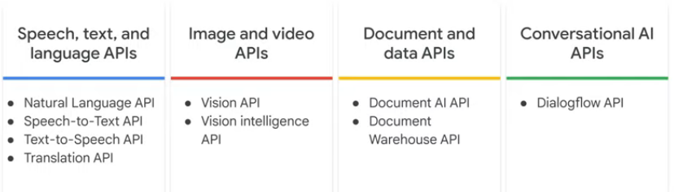

**--- Natural Language APIs**

* Entities – Auto tagging, classification, Extraction.
* Sentiment – (Score, Magnitude) Customer feedback, Social network comments, conversations.
* Syntax – Dependency, Parse label, Part of speech, Lemma, Morphology.
* Categories

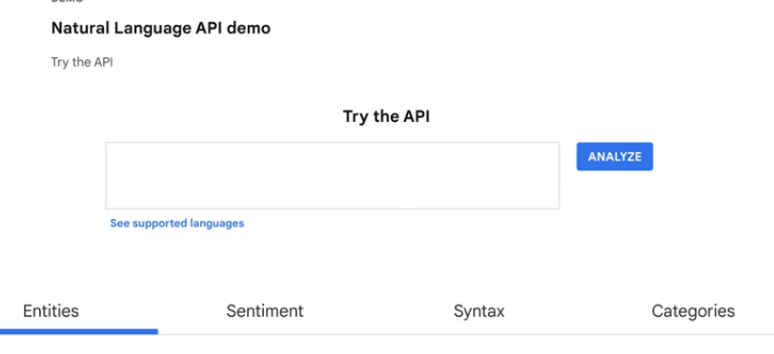

--- Vertex AI –

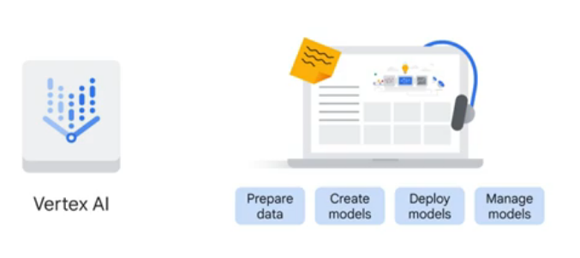

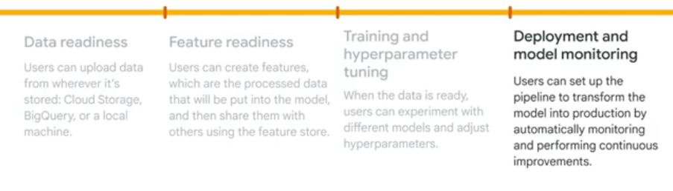

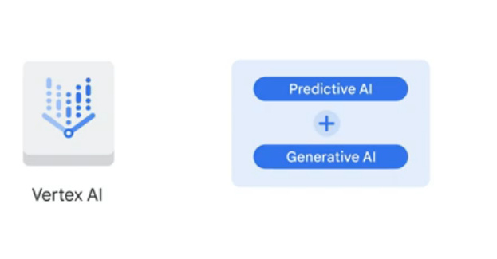

--- AutoML (Automatic Machine Learning)-

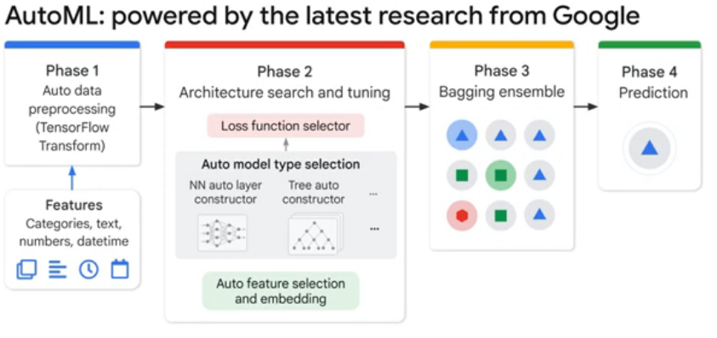

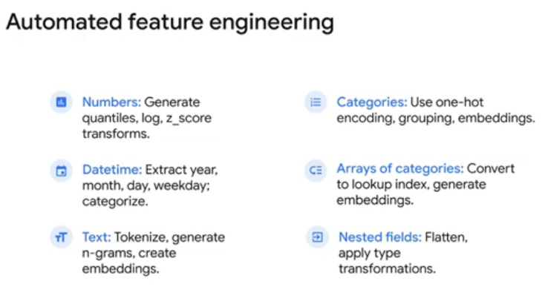

1. LLMs are trained for general purposes to solve common language problems, such as: text classification, question answering, document summarization, and text generation across industries.
2. Transfer learning is a powerful technique that lets people with smaller data sets or less computational power, achieve great results by using pre trained models trained on similar larger datasets. Because the model learns through transfer learning it doesn't have to learn from the beginning.

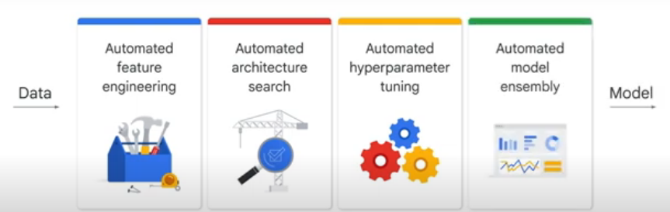

**--- Custom Training –**

If you want to create your own machine learning environment to experiment with and build your own pipeline, you need custom training.

Before any coding begins, you must determine what environment you want your ML training code to use.

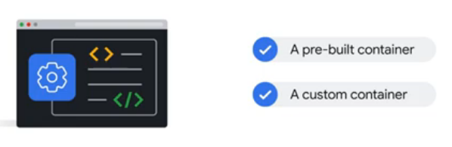

You can also use **Colab Enterprise**, which was integrated into Vertex AI platform in 2023, so data scientists can code in a familiar environment.

An **ML library** is a collection of pre written code that can be used to perform machine learning tasks. These libraries can save developers time and effort by providing them with the tools they need to build machine learning models without having to write everything from the beginning.

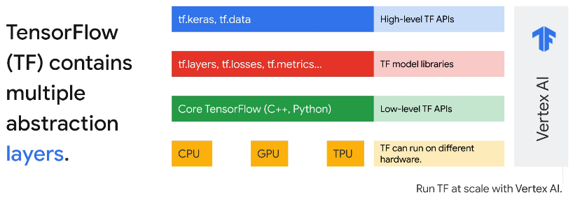

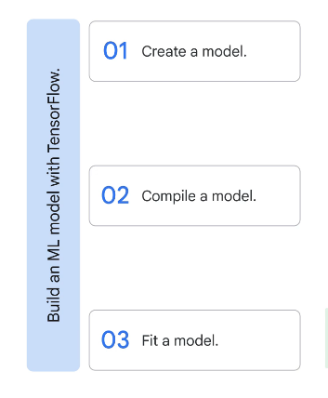

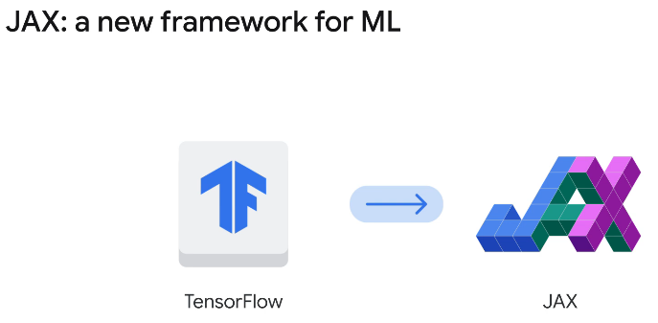

Apart from TensorFlow, Google is constantly introducing new frameworks. One of the most promising frameworks is **JAX**. JAX is a ***high performance numerical computation library*** that is highly flexible and easy to use. It offers new possibilities for both research and production environments.

**------------------------------ AI Development Options ---------------------------------**

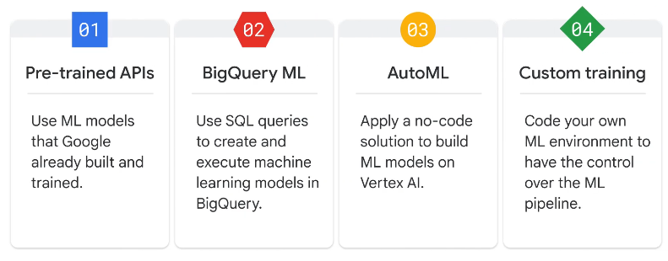

------------------------------------ ML Workflow ------------------------------------------------------

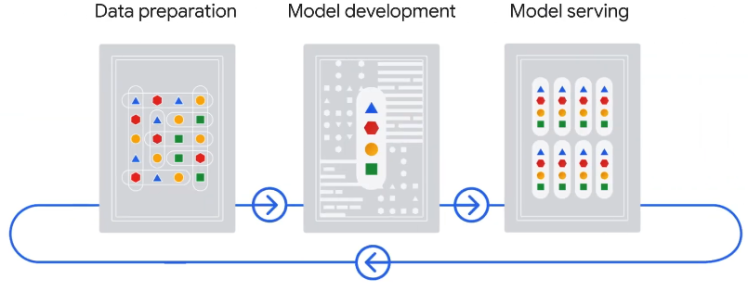

Two options to set up the workflow with Vertex AI ---

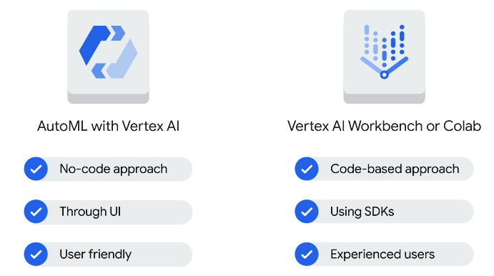

--------------------------------- Data Preparation --------------------------------------

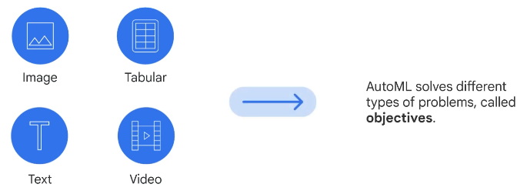

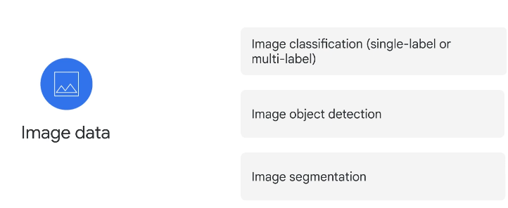

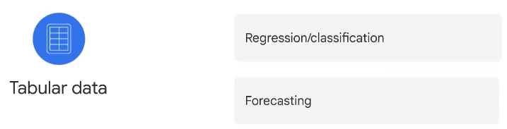

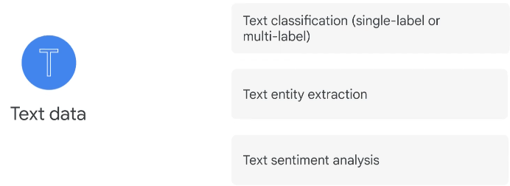

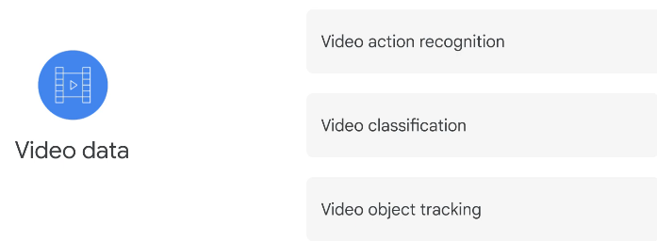

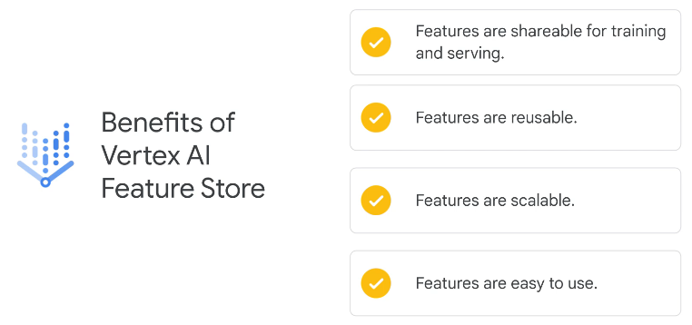

------------------------------------- Model Development ------------------------------------

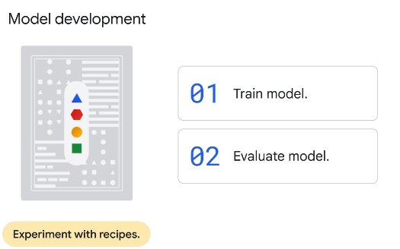

Vertex AI provides extensive evaluation metrics to help determine a model's performance.

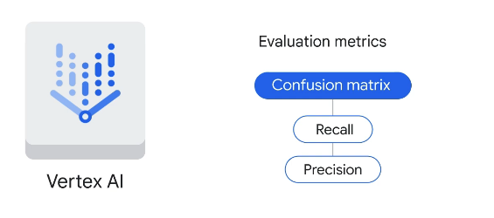

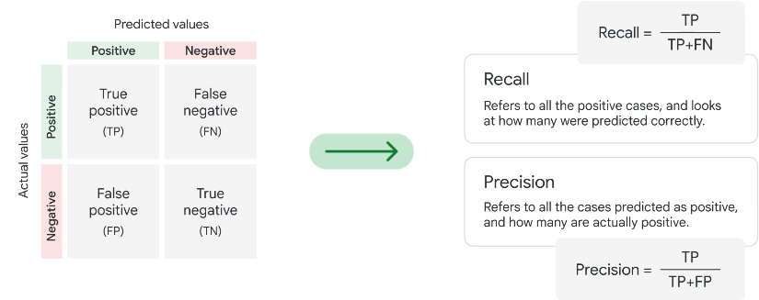

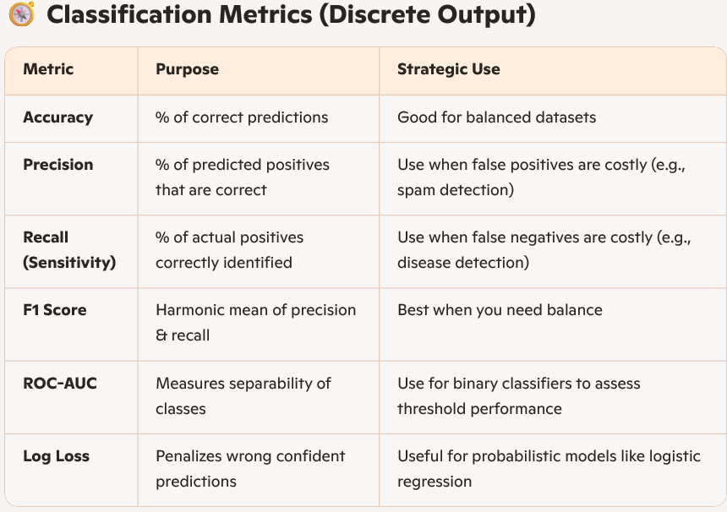

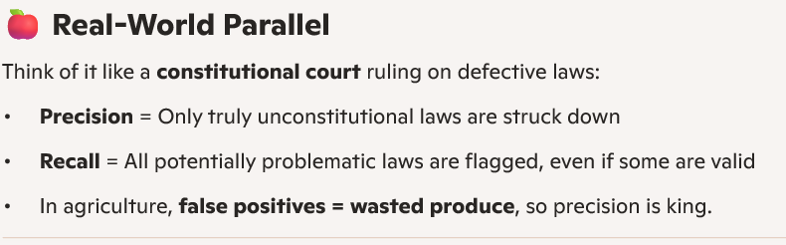

**Recall** – the number of Predicted correct out of all corrects. (as many cases as possible)

**Precision** – The number of actual correct out of all predicted. (actual cases)

A **confusion matrix** is a specific performance measurement for machine learning classification problems. The **confusion matrix** is a fundamental tool in ***classification*** tasks.

**Explainable AI** is a set of tools and frameworks to help understand and interpret predictions made by machine learning model.

**------------------------------------- Model Serving ------------------------------**

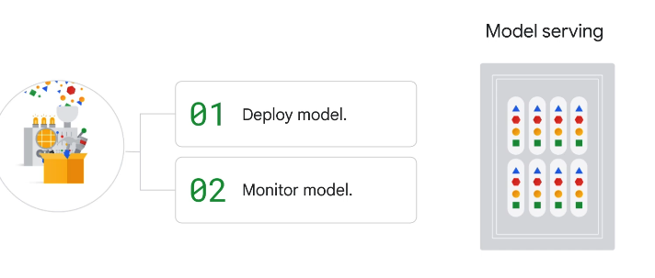

Two options to deploy models –

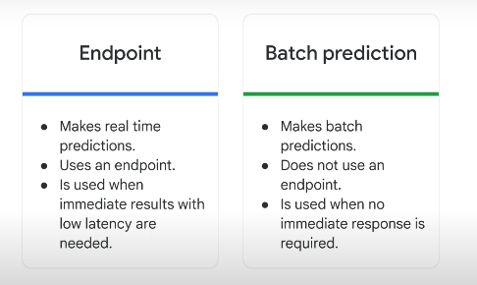

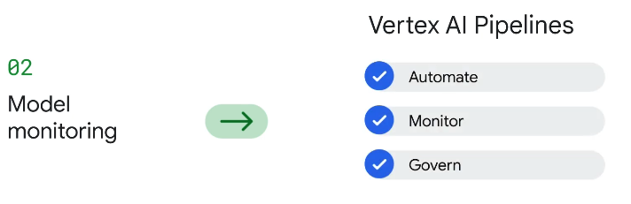

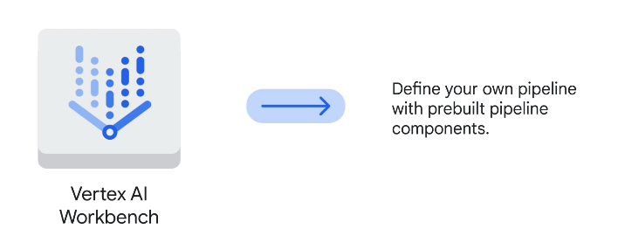

**------------------------------- MLOps -----------------------------------**

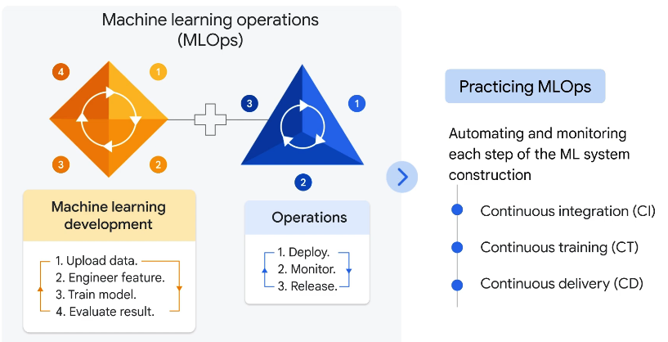

The backbone of MLOps on Vertex AI is a toolkit called ***Vertex AI Pipelines***, which supports both *Kubeflow Pipelines*, or KFP, and *TensorFlow Extended*, or TFX.

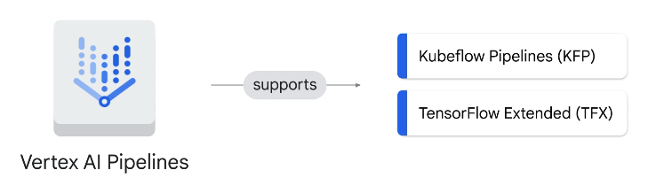

***If you already use TensorFlow to build ML models that process terabytes of structured data, it makes sense to use TFX and turn that code into an ML pipeline.***

***Otherwise, KFP can be a good alternative.***

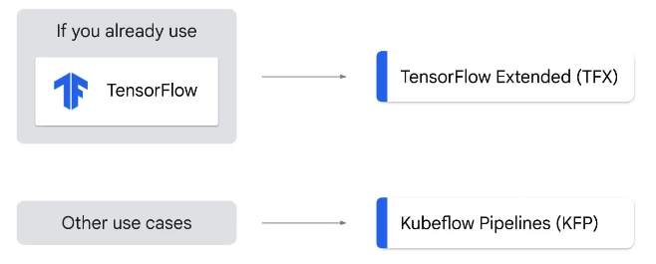

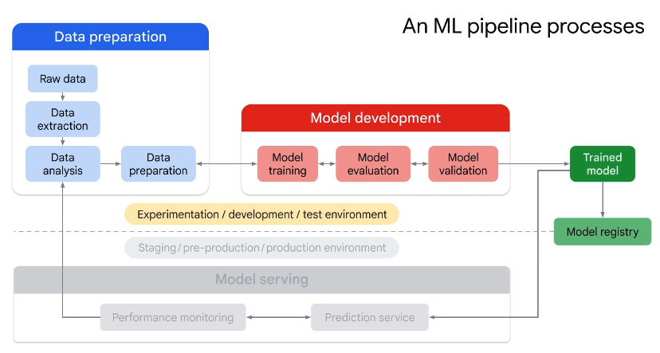

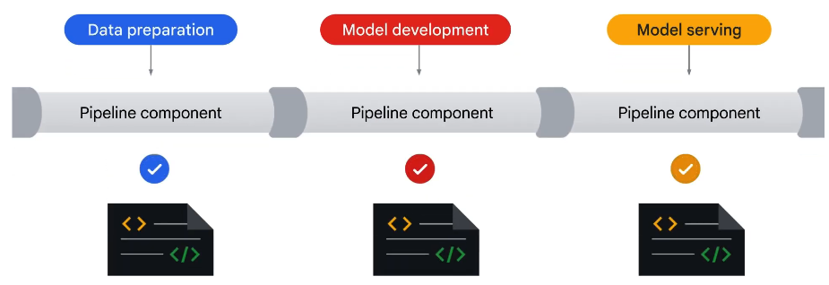

You can either build a custom component on your own or leverage the pre-built components provided by Google.

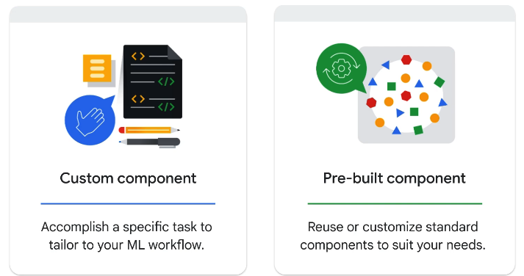

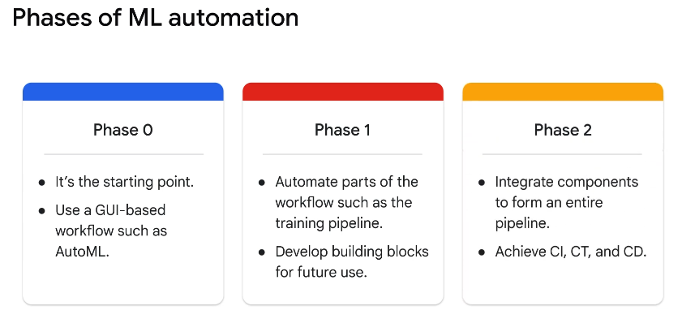

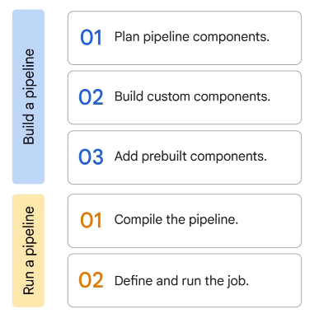

Vertex AI provides a few templates, like the one for classification/regression of tabular data with AutoML, to help you start your journey.

How Neural Networks Learn?

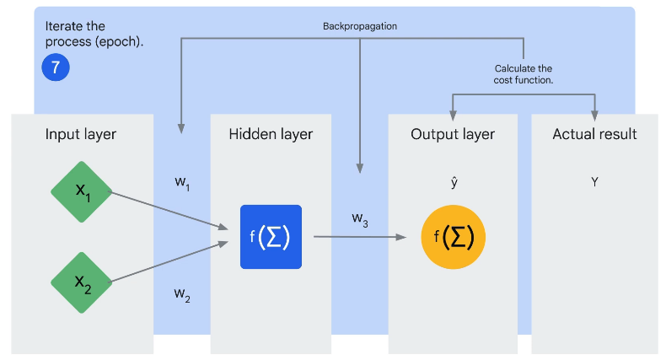

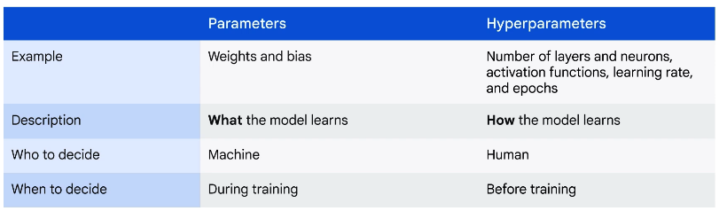

**====================== Prepare Data for ML APIs ============================**

**Dataprep** - [Dataprep by Alteryx Designer Cloud (Trifacta)](https://www.alteryx.com/products/designer-cloud) is an intelligent data service for visually exploring, cleaning, and preparing data for analysis. Cloud Dataprep is serverless and works at any scale. There is no infrastructure to deploy or manage. Easy data preparation with clicks and no code!

**Dataflow** - To create a streaming pipeline using one of [Google's Dataflow templates](https://cloud.google.com/dataflow/docs/templates/provided-templates). More specifically, you use the Pub/Sub to BigQuery template, which reads messages written in JSON from a Pub/Sub topic and pushes them to a BigQuery table.

**Dataproc** - Dataproc is a fast, easy-to-use, fully-managed cloud service for running [Apache Spark](http://spark.apache.org/) and [Apache Hadoop](http://hadoop.apache.org/) clusters in a simpler, more cost-efficient way. Operations that used to take hours or days take seconds or minutes instead. Create Dataproc clusters quickly and resize them at any time, so you don't have to worry about your data pipelines outgrowing your clusters.

**Natural language processing (NLP)** - The Cloud Natural Language API is a cloud-based service that provides natural language processing capabilities. It can be used to analyze text, identify entities, extract information, and answer questions.

**The Speech-to-Text** API allows you to send audio and receive a text transcription from the service.

**Google Cloud Video Intelligence** makes videos searchable and discoverable by extracting metadata with an easy to use REST API. You can now search every moment of every video file in your catalog. It quickly annotates videos stored in [Cloud Storage](https://cloud.google.com/storage/), and helps you identify key entities (nouns) within your video; and when they occur within the video. Separate signal from noise by retrieving relevant information within the entire video, shot-by-shot, -or per frame.

**============================ Vertex AI Notebooks ===========================**

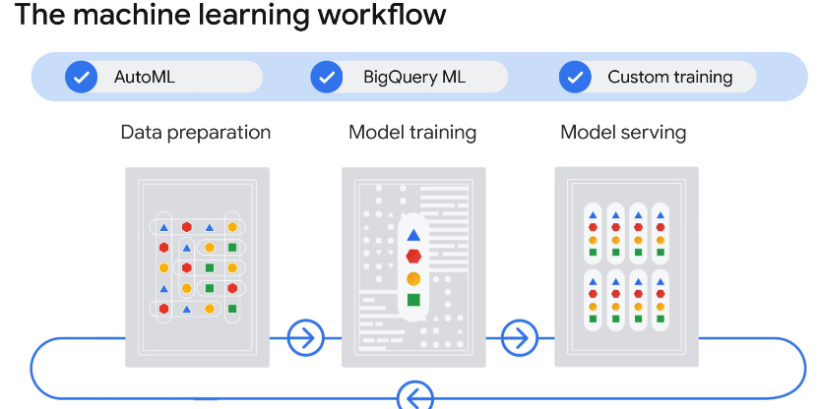

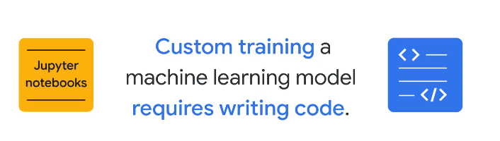

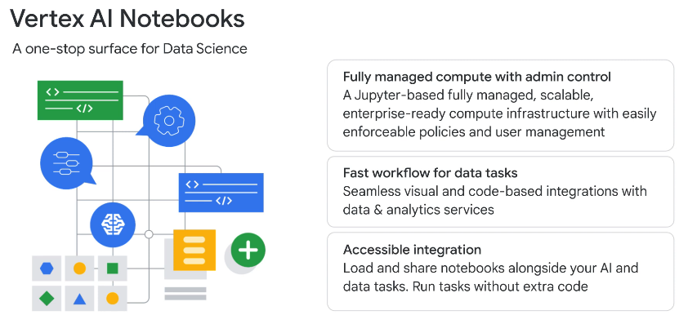

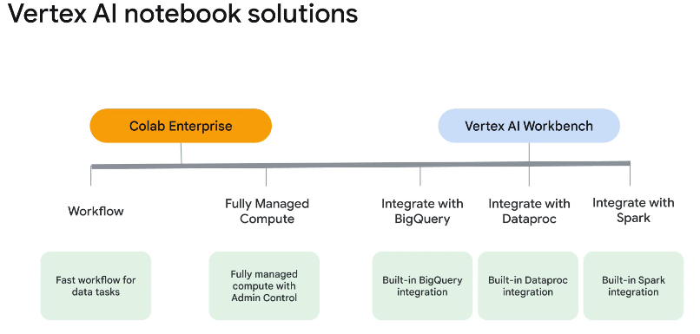

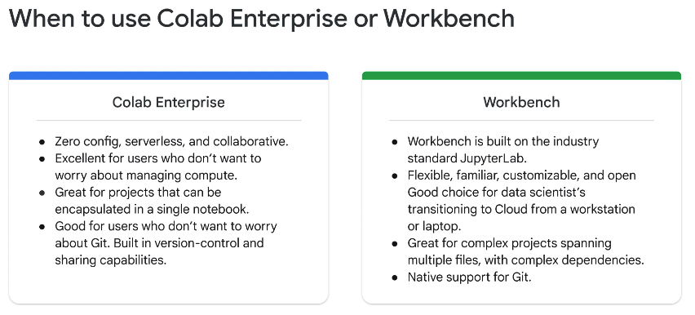

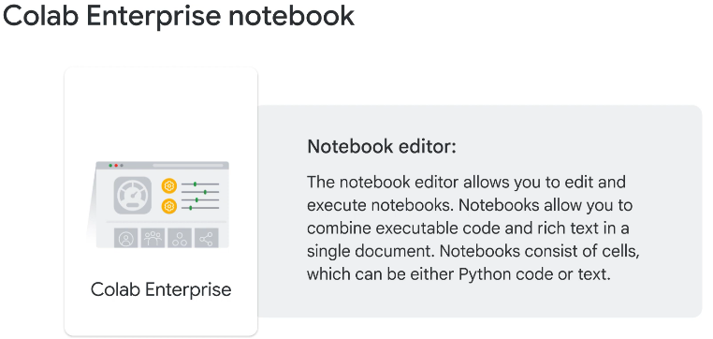

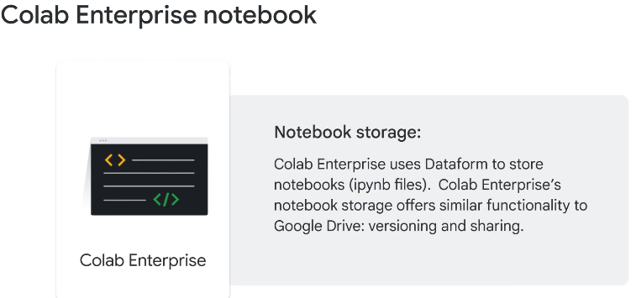

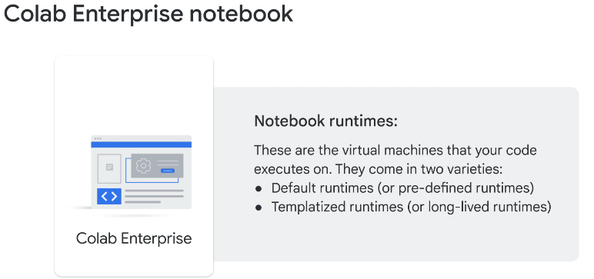

------------------

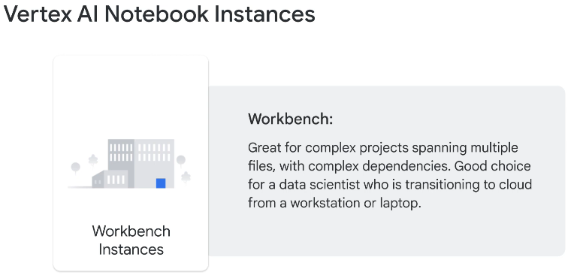

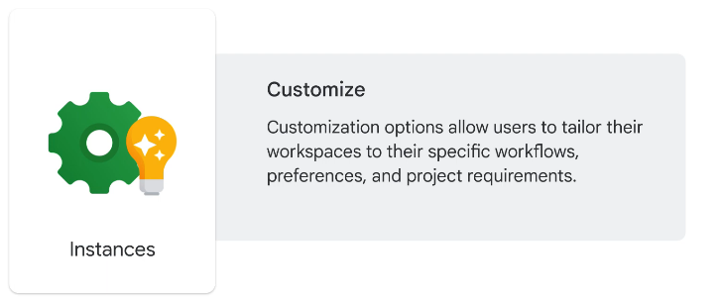

**Vertex AI Workbench** instances give you the most control over your Jupyter Notebook environment.

**DataProc** is a fully managed cloud service for running big data processing, analytics, and machine learning workloads on Google Cloud.

**Vertex AI Workbench** is a good option for projects that *prioritize control and customizability. It’s great for complex projects spanning multiple files, with complex dependencies*. It’s also a good choice for a data scientist who is transitioning to the cloud from a workstation or laptop.

Vertex AI Workbench Instances comes with a preinstalled suite of deep learning packages, including support for the TensorFlow and PyTorch frameworks.

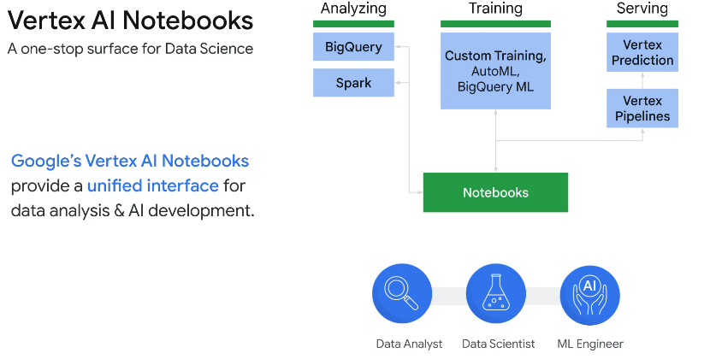

**Notebooks Difference =====================================================**

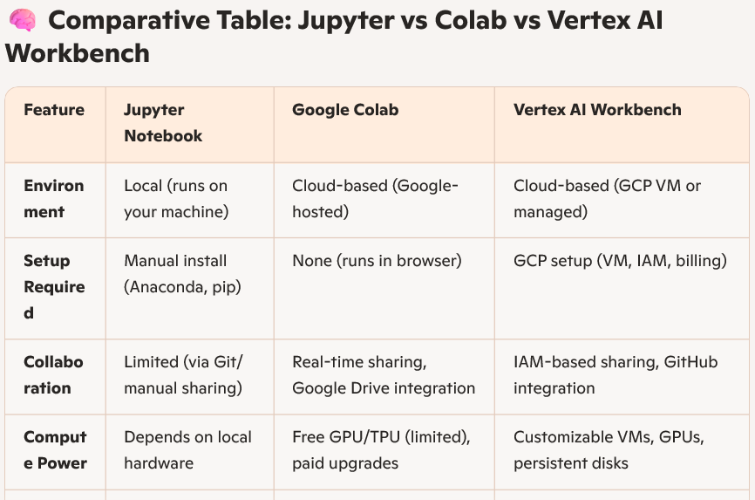

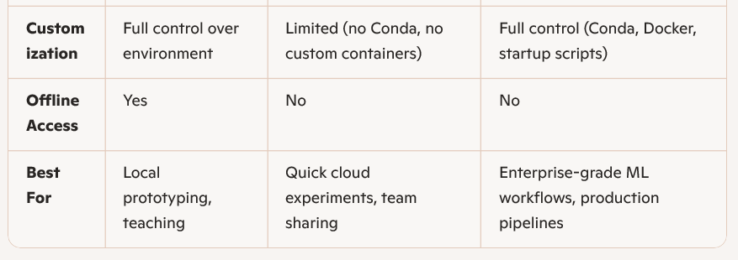

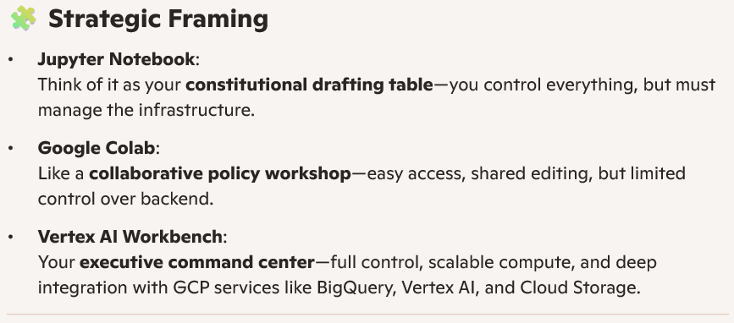

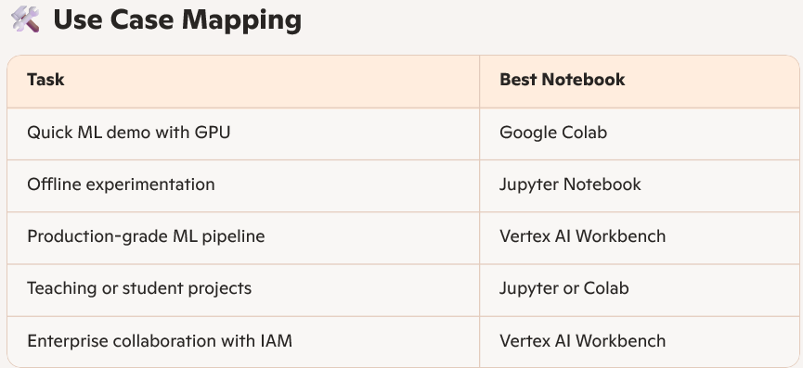

=================== ML Model with BigQuery ==============================

[**BigQuery ML**](https://cloud.google.com/bigquery/docs/bigqueryml-intro) enables users to *create and execute machine learning models in BigQuery using SQL queries*. The goal is to democratise machine learning by enabling SQL practitioners to build models using their existing tools and to increase development speed by eliminating the need for data movement.

**BigQuery** is Google's fully managed, NoOps, low cost analytics database. With BigQuery you can query terabytes and terabytes of data without having any infrastructure to manage or needing a database administrator. BigQuery uses SQL and can take advantage of the pay-as-you-go model. BigQuery allows you to focus on analyzing data to find meaningful insights.

[**BigQuery ML**](https://cloud.google.com/bigquery/docs/bigqueryml) is a feature in BigQuery that data analysts can use to create, train, evaluate, and predict with machine learning models with minimal coding.

========================== Feature Engineering ==========================

What is “**feature**” in machine learning - A value that is passed as input to a model.

**Feature registry** – Where features are registered.

**Vertex AI Feature Store Solutions** –

* Mitigate training-serving skew, which occurs when the feature data distribution that you use in production differs from the feature data distribution that was used to train your model.
* Detect drift, as a result of significant changes to your feature data distribution over time.
* Mitigate data storage **silos**, which occurs when you might have built and managed separate solutions for storage and the consumption of feature values.

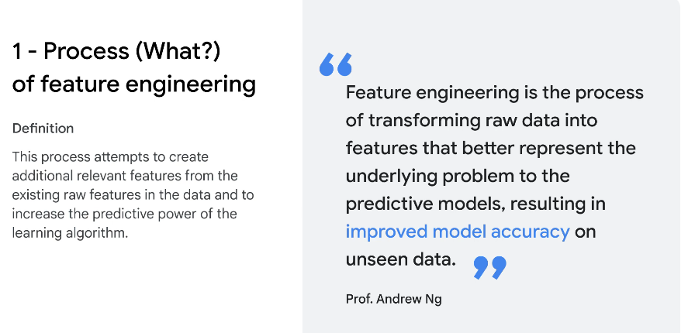

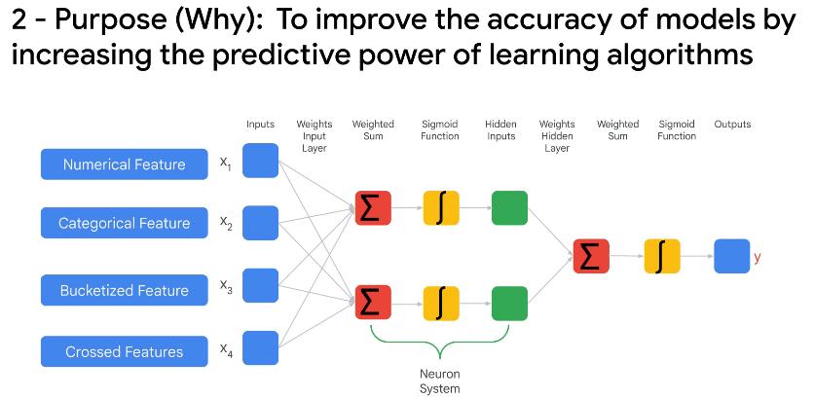

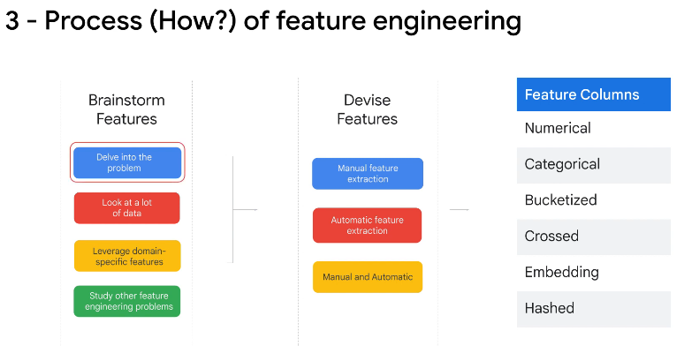

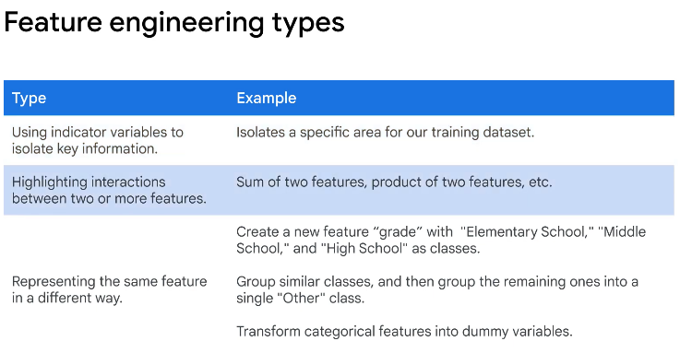

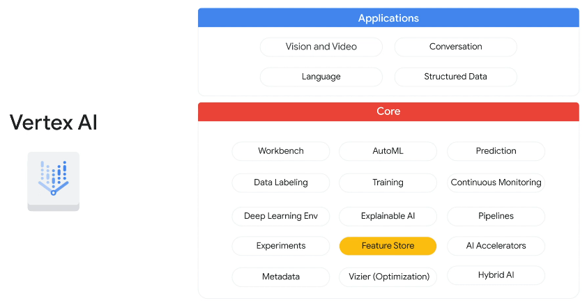

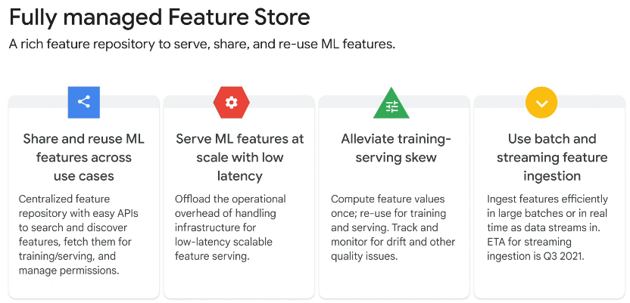

The Feature Store data model includes an entity type, entities, features, and feature values.

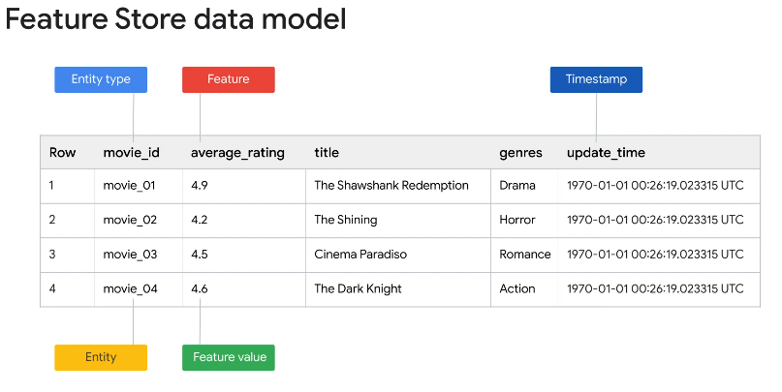

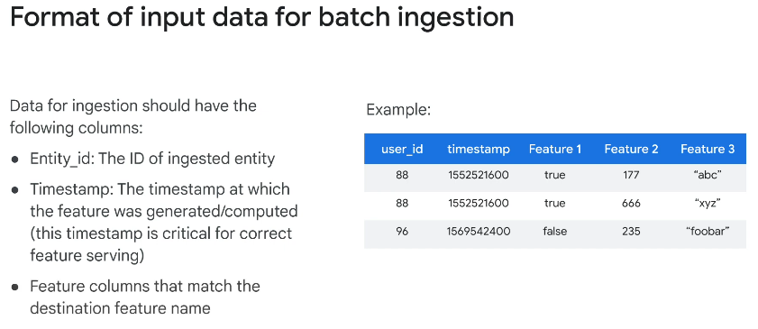

Different problems in the same domain may need different features.

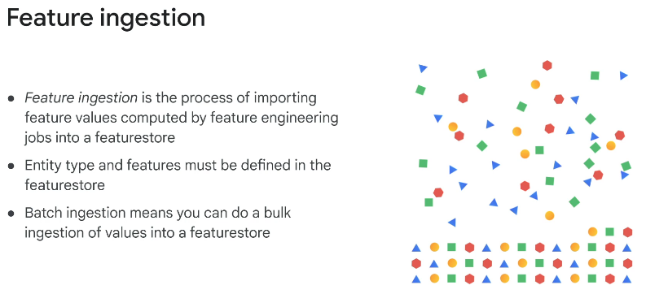

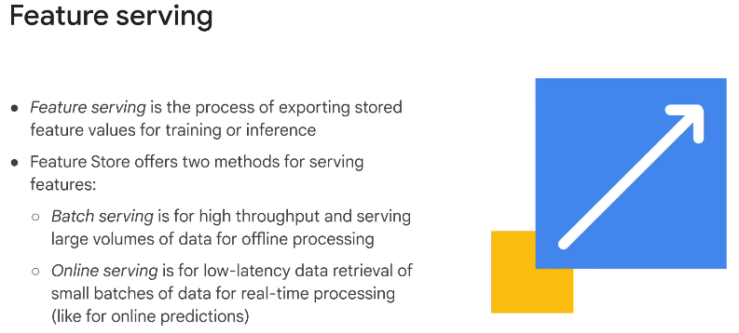

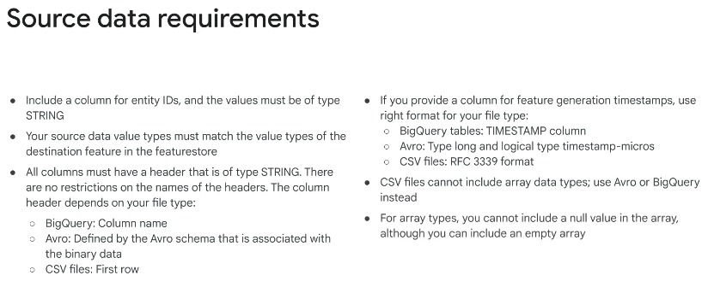

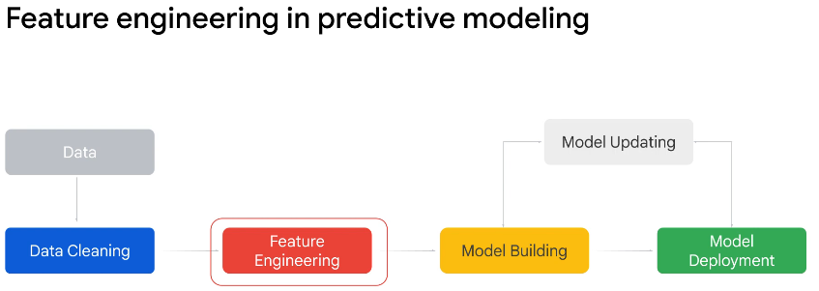

BigQuery preprocessing involves two aspects -

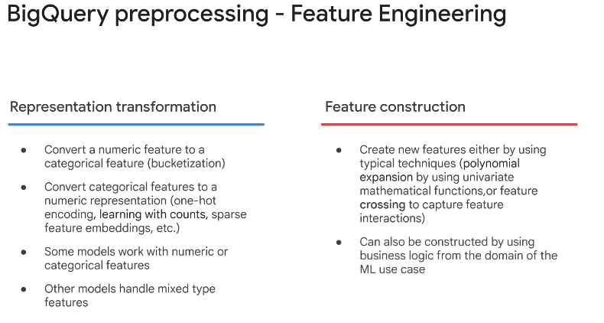

BigQuery ML supports two types of feature preprocessing, automatic and manual.

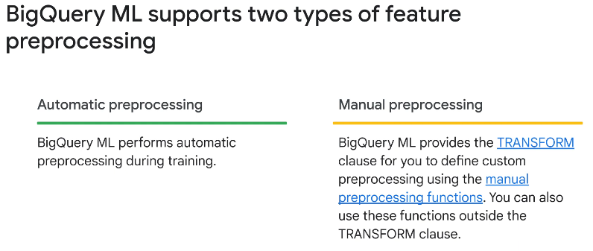

Feature Crosses –---------------------------------------

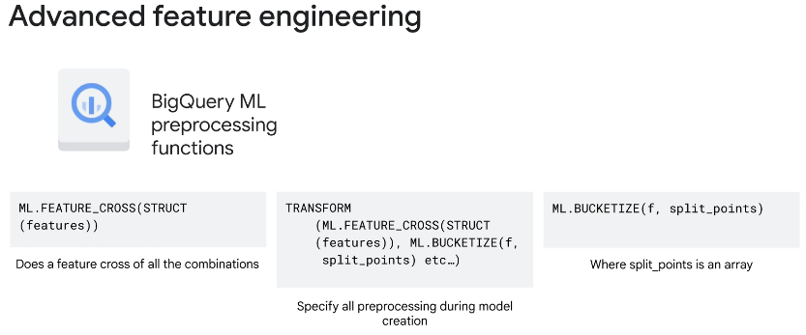

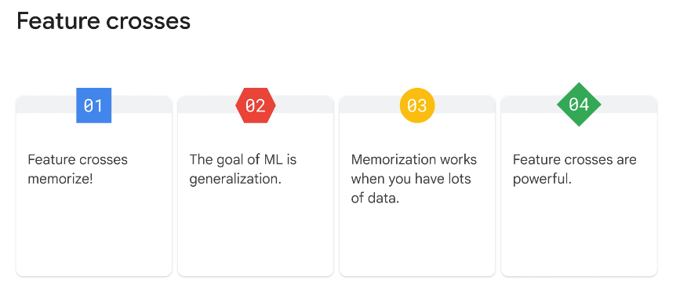

**Bucketize ---------------------------------------------------**

Before we perform our prediction, we should encapsulate the entire feature set in a TRANSFORM clause.

The input columns of the TRANSFORM clause are the query expression, as select part.

The output columns of TRANSFORM from select list are used in training.

The advantage of encapsulating features in the TRANSFORM clause is that the client code doing predict, doesn't change. That is, our model improvement is transparent to client code. Note that the TRANSFORM clause must be placed after the CREATE statement.

TRANSFORM clause ensures that transformations are automatically applied during prediction.

In Summary all the columns types –

1. Numeric
2. Categorical
3. Bucketized
4. Cross
5. Embedding
6. Hashing

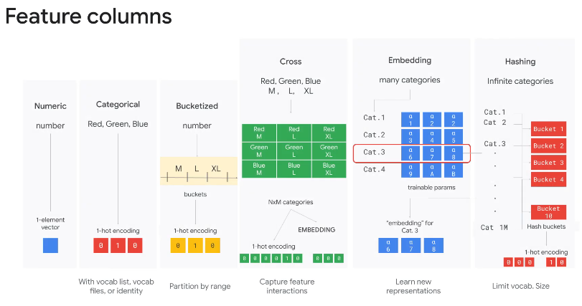

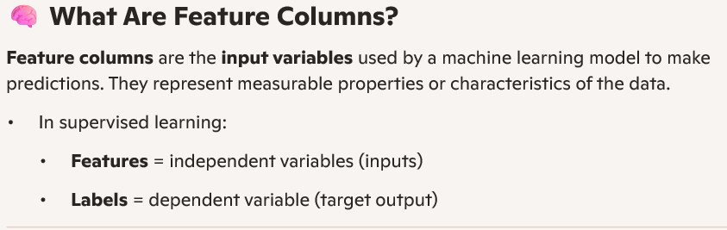

**Feature Cross** - A feature cross is a synthetic feature formed by multiplying (crossing) two or more features. Crossing combinations of features can provide predictive abilities beyond what those features can provide individually.

* Feature Cross enables a model to ***learn separate weights for each combination*** of features.
* It is a process of ***combining features into a single feature***.

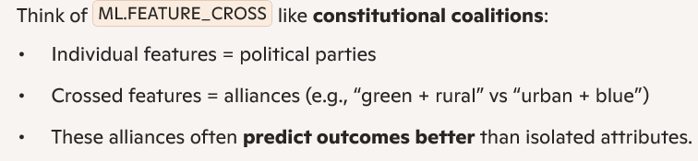

**One-hot encoding** transforms each *category in a feature into a separate binary column*:

* A value of **1** indicates the presence of that category.
* A value of **0** indicates its absence.
* One-hot encoding is a process by which categorical variables are converted into a form that could be provided to neural networks to do a better job in prediction.

**ML.EVALUATE** –

* The ML.EVALUATE function evaluates the predicted values against the actual data.
* You can use the ML.EVALUATE function to evaluate model metrics.
* The ML.EVALUATE function can be used with linear regression, logistic regression, k-means, matrix factorization, and ARIMA-based time series models.

**ML.BUCKETIZE -**

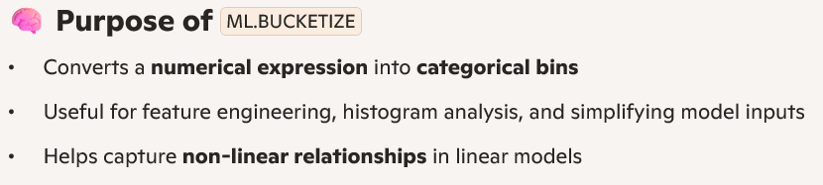

The **tf.feature_column.bucketized_column ()** function in **TensorFlow** is used –

* To ***convert a continuous numerical feature into discrete bucket***
* To **discretize floating point values** into a **smaller number of categorical bins**.

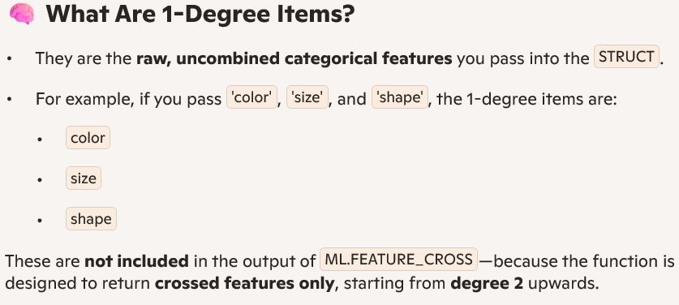

**==================== DataFlow Apache Beam Pipeline ========================**

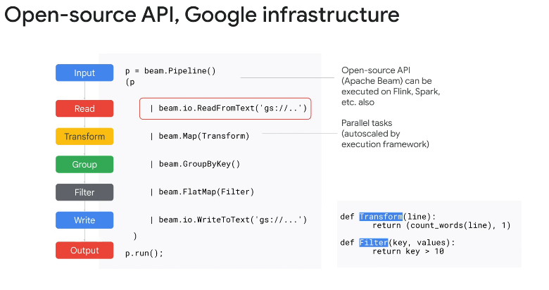

Apache Beam is the API for data pipeline building in Java or Python and Dataflow is the implementation and execution framework.

Anything in Map or FlatMap can be **parallelized** by the Beam execution framework.

A **ParDo** acts on one item at a time (like a Map in MapReduce)

**WriteToText** – Output

**Runner** - Run the pipeline

**Transform** – Each step is called transform.

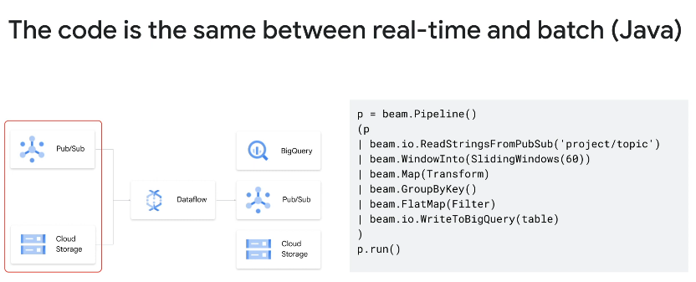

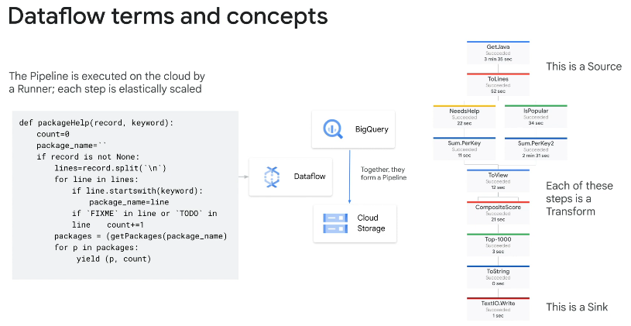

======================= TensorFlow Transform ==============================

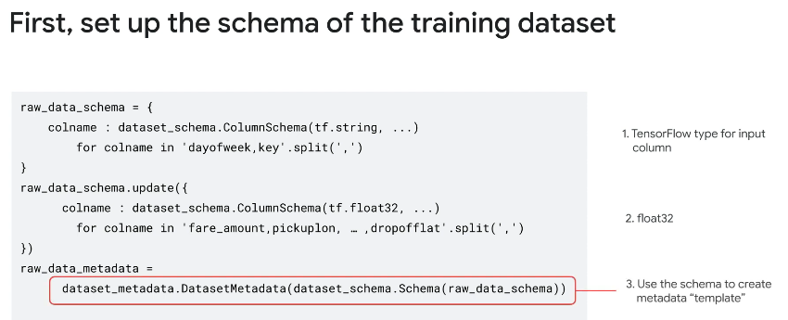

Exam Preparation

You developed an ML model –

You have developed a very large network in TensorFlow Keras –

You use Vertex AI Workbench to develop model training and batch inference with an XGBoost model –

You developed a tree model –

You need to develop an online model prediction service –

1. *Cloud Composer is not a cost-efficient solution for one pipeline because its environment is always active. In addition, using BigQuery is not the most cost-effective solution.*
2. *Vertex AI Pipelines and Cloud Storage are cost-effective and secure solutions.*
3. *Using* ***email*** *to send personally identifiable information (PII) is not a recommended approach.*
4. *MirroredStrategy only supports multiple GPUs on one instance, which may not be as performant as running on multiple instances.*
5. *GPUs are the correct hardware for deep learning training with high-precision training, and distributing training with multiple instances will allow maximum flexibility in fine-tuning the accelerator selection to minimize execution time. Note that one worker could still be the best setting if the overhead of synchronizing the gradients across machines is too high, in which case this approach will be equivalent to MirroredStrategy.*
6. *TPUs are not recommended for workloads that require high-precision arithmetic, and are recommended for models that train for weeks or months. So this is not optimal for minimizing time.*
7. *You require anonymizing personally identifiable information (PII), which you have identified in your feature set using the Cloud Data Loss Prevention API.*

* *Hashing is the best which is an* ***irreversible transformation*** *that ensures anonymization and does not lead to an expected drop in model performance because you keep the same feature set while enforcing referential integrity.*
* *Masking does not enforce* ***referential integrity****, and a drop in model performance may happen.*

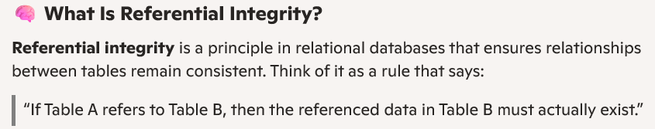

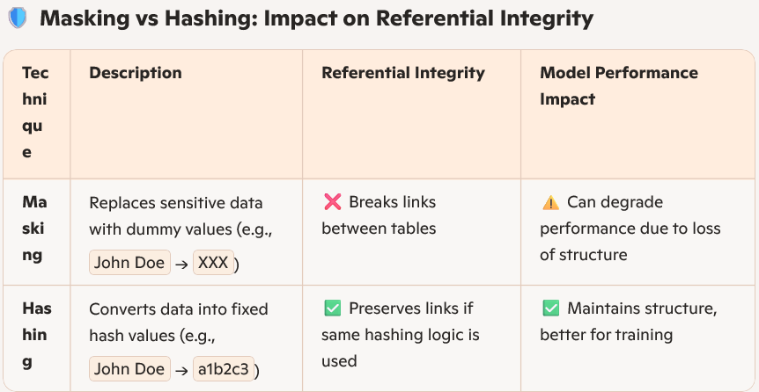

* ***Anonymization*** *is the process of transforming data so that it* ***cannot be linked back to an individual****, either directly or indirectly.*

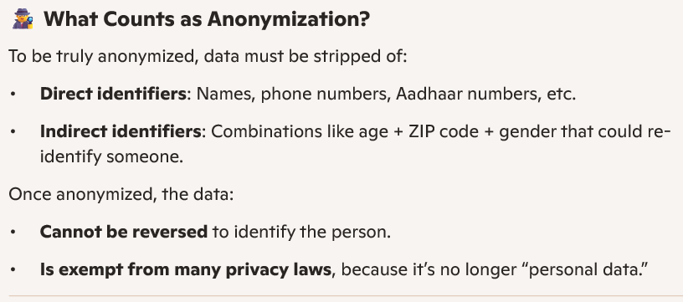

* *Deterministic encryption is reversible, and anonymization requires irreversibility. Also, tuning the existing model is not recommended because the model training on the original dataset may have memorized sensitive information.*

1. *You want to select a training method that reliably detects Post-it Notes of any relative size in the image and that minimizes the time to train a model? –*

* *The object detection capability of the* ***Cloud Vision API*** *confidently detects large objects within the image and is not the best option to reliably detect sticky notes of any relative size in the image.*
* ***AutoML*** *is a codeless solution that minimizes time to train and develop the model, and it is capable of detecting bounding boxes up to one percent the length of a side of an image. AutoML achieves state-of-the-art performance even on tiny objects (8-32 pixels).*
* ***Creating a custom training job*** *requires more development time than using AutoML does.*

1. *You want to orchestrate the model retraining pipeline to run on a weekly schedule while minimizing cost and implementation effort? –*

* ***Vertex AI Workbench*** *does not provide alerts, and you would have to log in every week to check the pipeline run status. This does not minimize monitoring steps.*
* ***Cloud Composer*** *does not provide ML-specific monitoring capabilities. Also, unless many pipelines are hosted in Cloud Composer, this solution is not the most cost-efficient.*
* ***Kubeflow Pipelines SDK*** *is the best practice to orchestrate AI pipelines with modular steps. - Supports continuous training (CT) and continuous deployment (CD) for evolving models. Pipelines can be triggered via Git commits, scheduled jobs, or external APIs.* *- Each step in the pipeline is defined as a Python function and - These components are containerized, making them reusable, version-controlled, and language-agnostic.*

1. *You need to develop an online model prediction service that accesses pre-computed near-real-time features and returns a customer churn probability value. The features are saved in BigQuery and updated hourly using a scheduled query. You want this service to be low latency and scalable and require minimal maintenance? –*

* ***Vertex AI Feature Store*** *with* ***BigQuery*** *prioritizes low latency, scalability, requires minimal maintenance, and facilitates integration with other Vertex AI services as a fully managed solution.*
* *Using* ***Google Kubernetes Engine*** *increases maintenance.*
* *Vertex AI Feature Store is not as low-latency as Memorystore.*
* ***Feature lookup*** *and* ***model inference*** *can be performed in Cloud Function*

1. *You have verified that no alert was logged in any of the ML system’s monitoring systems and that the pipeline code has not been updated recently. You want to assure the quality of the pipeline results as quickly as possible so you can determine whether to deploy the trained model? –*

* ***TensorBoard*** *provides a compact and complete overview of training metrics such as loss and accuracy over time. If the training converges with the model’s expected accuracy, the model can be deployed.*
* ***Model size*** *is a good indicator of health but does not provide a complete overview to make sure that the model can be safely deployed. Note that the pipeline’s metadata can also be accessed directly from Vertex AI Pipelines.*

1. *You want to configure a comprehensive monitoring solution for training-serving skew that requires minimal maintenance? –*

* ***Vertex AI Model Monitoring*** *is a fully managed solution for monitoring training-serving skew that, by definition, requires minimal maintenance. Using the console for diagnostics is recommended for a comprehensive monitoring solution because there could be multiple causes for the skew that require manual review.*
* ***Model retrain*** *does not necessarily fix skew. For example, differences in pre-processing logic between training and prediction can also cause skew.*
* *Here* ***update the model hosted on Vertex AI*** *is not minimal maintenance. It involves multiple custom components that require additional updates for any schema change.*

1. *You want to* ***remove age bias*** *while maintaining similar offline performance? –*

* *Review the data distribution for each feature against the* ***bucketized******age column*** *for the training and evaluation sets, and introduce preprocessing to even irregular feature distributions.*

1. *You want to reduce latency while minimizing the offline performance drop and modifications to the model before deploying the model to production? –*

* ***Post-training quantization*** *is the recommended option for reducing model latency when re-training is not possible. Post-training quantization can minimally decrease model performance.*
* ***Tuning*** *the whole model on the custom dataset will cause a drop in offline performance.*
* ***Pruning*** *helps in compressing model size, but it is expected to provide less latency improvements than quantization.*

1. *You want to update the training regime to maximize the convergence of both losses and reduce overfitting? –*

* ***Changing the learning rate*** *does not reduce overfitting. Increasing the number of training* ***epochs*** *is not expected to improve the losses significantly.*
* ***L1 regularization*** *could be used to stabilize the learning, but it is not expected to be particularly helpful because only the most relevant features have been used for training.*
* ***L2 regularization*** *prevents overfitting. Increasing the model’s complexity boosts the predictive ability of the model, which is expected to optimize loss convergence when underfitting.*

1. *You want to define a rollout strategy for the new model version that guarantees an optimal user experience with zero downtime? –*

* *Release the* ***new model version in a new Vertex AI endpoint****. Update the application to send all requests to both Vertex AI endpoints, and log the predictions from the new endpoint. If the new version is successful, route all traffic to the new application. Because* ***shadow deployments*** *minimize the risk of affecting user experience while ensuring zero downtime.*
* ***Shadow deployments -*** *Shadow deployment is a risk-free strategy used in software and machine learning systems to test new versions of models or applications without impacting end users. Think of it as running a "ghost version" of your system in parallel with production.*
* ***Canary deployments*** *may affect user experience, even if on a small subset of users. Canary deployments are a progressive rollout strategy (traffic-split) where a new version of a model or application is released to a small subset of users first, before gradually expanding to the full user base.*

1. *Your primary focus for the pipeline is model interpretability. You want to productionize the pipeline as quickly as possible? –*

* ***Interpretability*** *in a pipeline means embedding* ***transparency and traceability*** *into every stage of your AI workflow—not just the model itself. It’s the ability to understand, trace, and explain.*
* ***Tabular Workflows for Wide & Deep*** *is capable of handling classification and regression pipelines, it’s optimized for memorization and generalization, and in general deep learning-based models are* ***not*** *preferred for interpretability.*
* ***Cloud Composer*** *is* ***not*** *the right tool to build an ML pipeline quickly, and in general deep learning-based models are not preferred for interpretability.*
* *Building a pipeline on* ***Google Kubernetes Engine*** *would take a long time.*
* ***TabNet*** *uses sequential attention that promotes model interpretability and Tabular Workflows is a set of integrated, fully managed, and scalable pipelines for end-to-end ML with tabular data for regression and classification. TabNet is available on* ***Vertex******AI Tabular Workflow****.*

1. *You need to determine how to store and access the images for training. You want to maximize data throughput and minimize training time while reducing the amount of additional code? –*

* ***Cloud Storage*** *is* ***not*** *optimized for accessing lots of small files, as there is overhead in establishing the connections to retrieve each file.*
* *Although accessing a large archive via* ***serialized records*** *(TFRecords, WebDatasets) is faster than small files,* ***it’s still slower*** *than using* ***Filestore****.*
* ***Filestore*** *is faster than Cloud Storage for accessing files, and serialized records are faster for feeding training pipelines than individual files.*

1. *You want to minimize prediction latency and the effort required to update the model? –*

* ***Cloud Functions*** *will run into* ***limitations*** *based on request rate and model size.*
* *Expose the model as a Vertex AI endpoint.* ***Exposing the model*** *as an endpoint adds to the total latency*
* ***RunInference******API*** *with a locally loaded model minimizes the prediction latency and makes model updates seamless.*
* ***Provisioning Vertex AI Pipelines*** *adds to the total latency.*

1. You want to ensure that training time is minimized without significantly compromising the accuracy of your model? –

* Modify the 'scale-tier' parameter.
* Here not use Epoch, Batch Size and Learning Rate.

1. ***Recurrent Neural Networks (RNNs)*** *are a class of neural networks designed to handle sequential data — where the order and context of inputs matter. Unlike feedforward networks, RNNs have a feedback loop that allows them to “****remember” previous inputs****, making them ideal for tasks like language modeling, time series prediction, and speech recognition. This is best fit to learn model with previous/historical data.*
2. ***TFRecords*** *optimizes storage for images. TFRecords are a binary file format developed by TensorFlow to store large datasets efficiently — especially useful when training deep learning models on structured or unstructured data like images, text, or audio.*
3. ***Collaborative filtering models****, a core technique in recommender systems, predict user preferences by analyzing interactions between users and items, i****dentifying similar users or items****, and recommending items liked by* ***similar users*** *or the user in question*